**Institute of Engineering & Management**

**Department of Computer Science & Engineering**

**Communication Engineering Laboratory for 2nd year 4th semester 2018**

**Code: CS 491**

**Date:** 18/9/18

**ASSIGNMENT-4**

**Experiment Name: Waveforms of high and low Duty cycles**

**Objective:** Generating and displaying waveform in two different frequencies for high and low duty cycle.

**Theory:** A duty cycle is the fraction of one period in which a signal or system is active. Duty cycle is commonly expressed as a percentage or a ratio. A period is the time it takes for a signal to complete an on-and-off cycle.  
  
   
  
where D is the duty cycle, PW is the pulse width (pulse active time), and T is the total period of the signal. Thus, a 60% duty cycle means the signal is on 60% of the time but off 40% of the time. The "on time" for a 60% duty cycle could be a fraction of a second, a day, or even a week, depending on the length of the period.

**Observation Table:**

Table for duty cycle of Square wave:

|  |  |
| --- | --- |
| Function Generator | Oscilloscope |

|  |  |  |  |  |
| --- | --- | --- | --- | --- |
| frequency | Volt(V) | Duty Cycle(%) | Vpp(V) | Frequency(kHz) |
|  |  |  |  |  |
|  |  |  |
|  |  |  |  |
|  |  |  |
|  |  |  |  |  |
|  |  |  |
|  |  |  |  |
|  |  |  |

**Waveforms:**

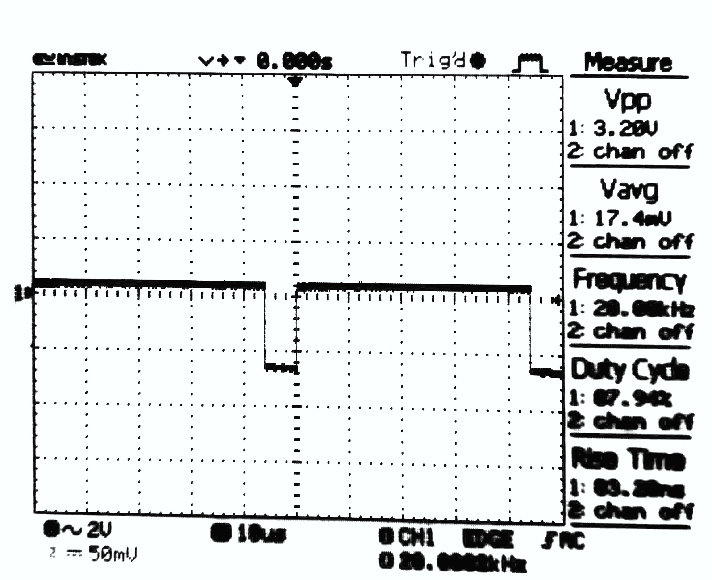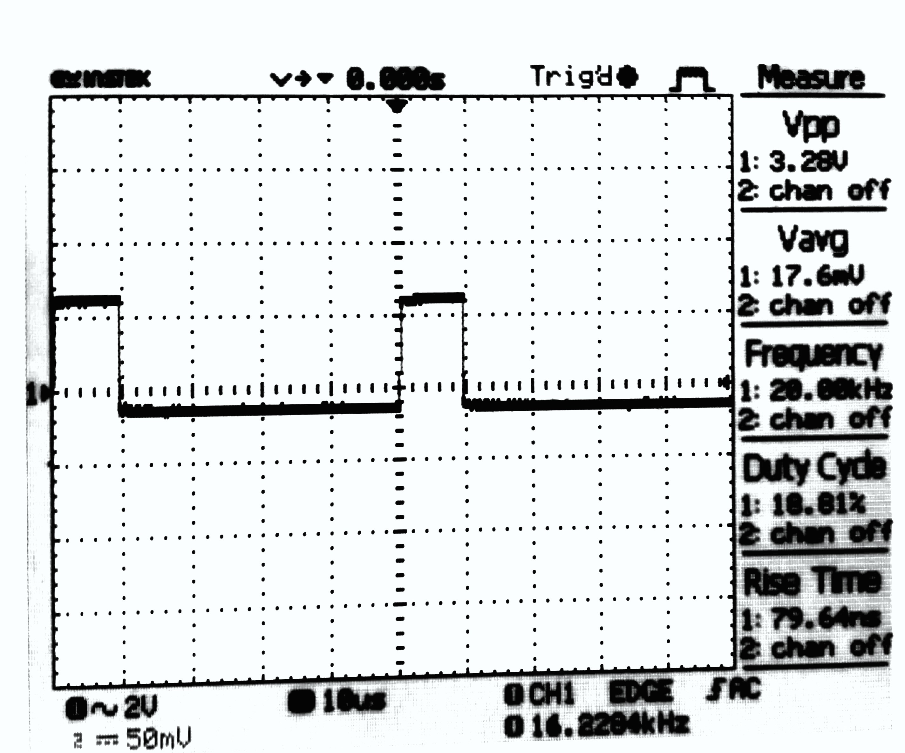

20kHz, Low duty cycle 20kHz, High duty cycle

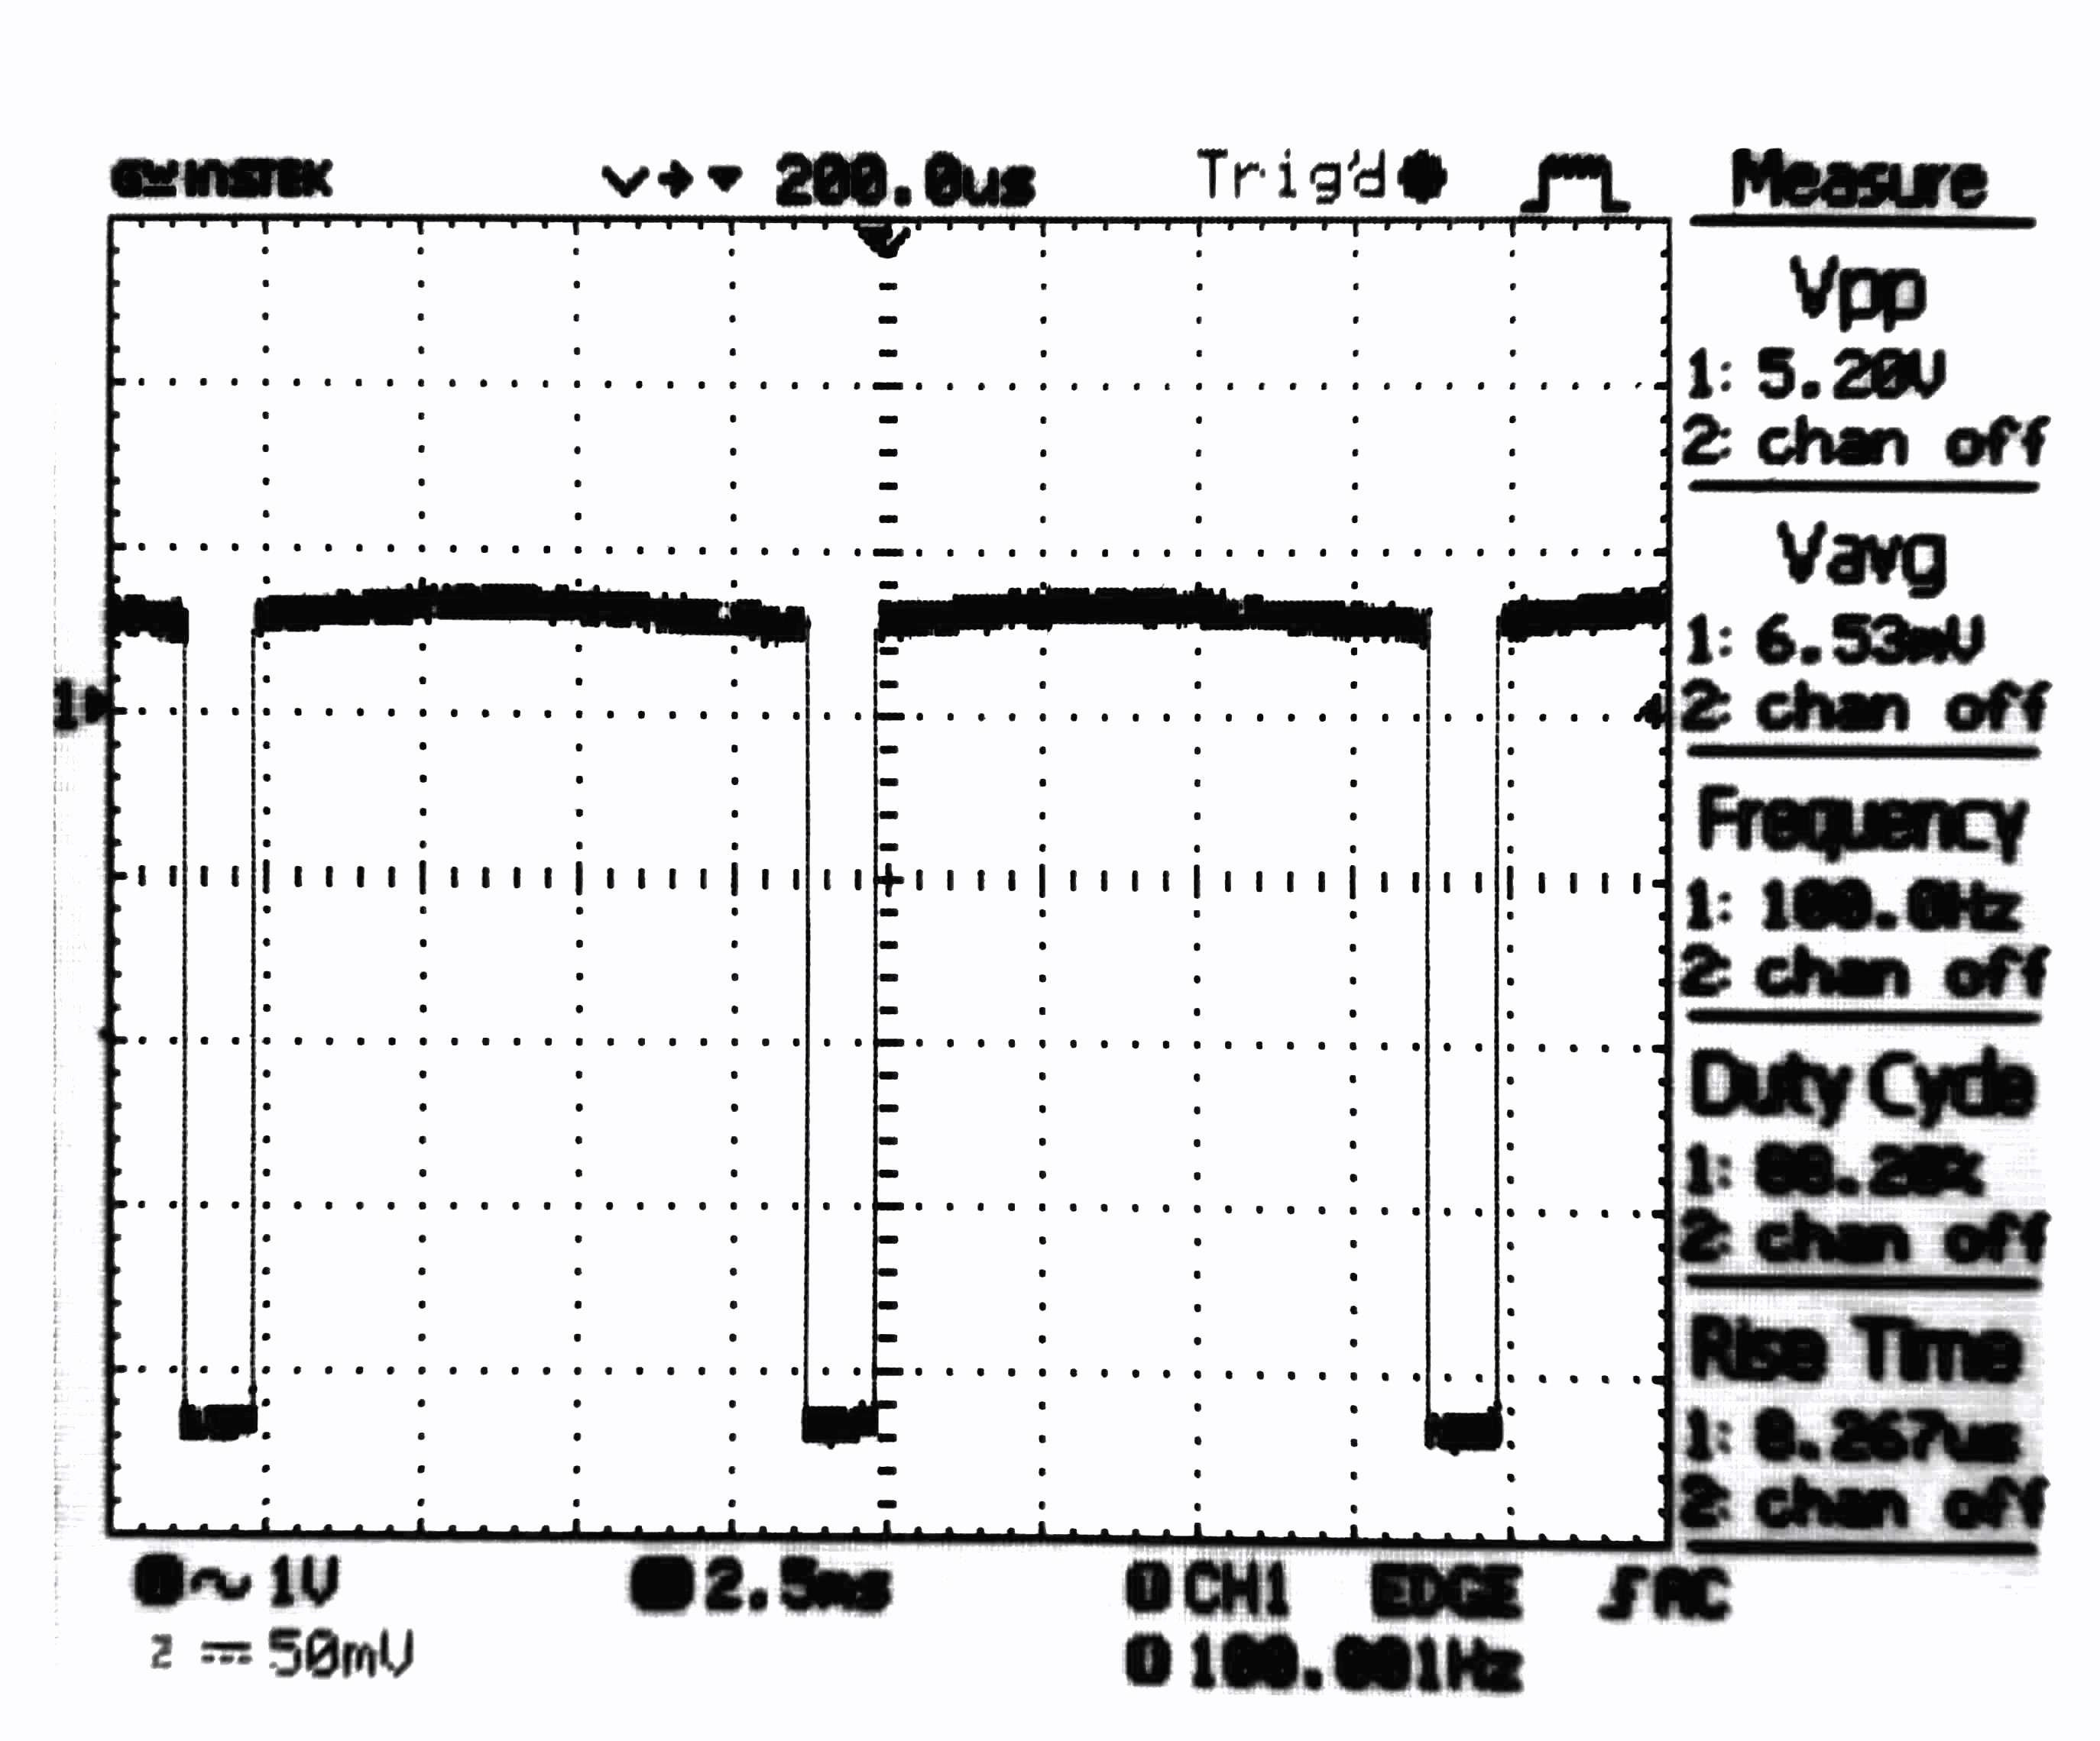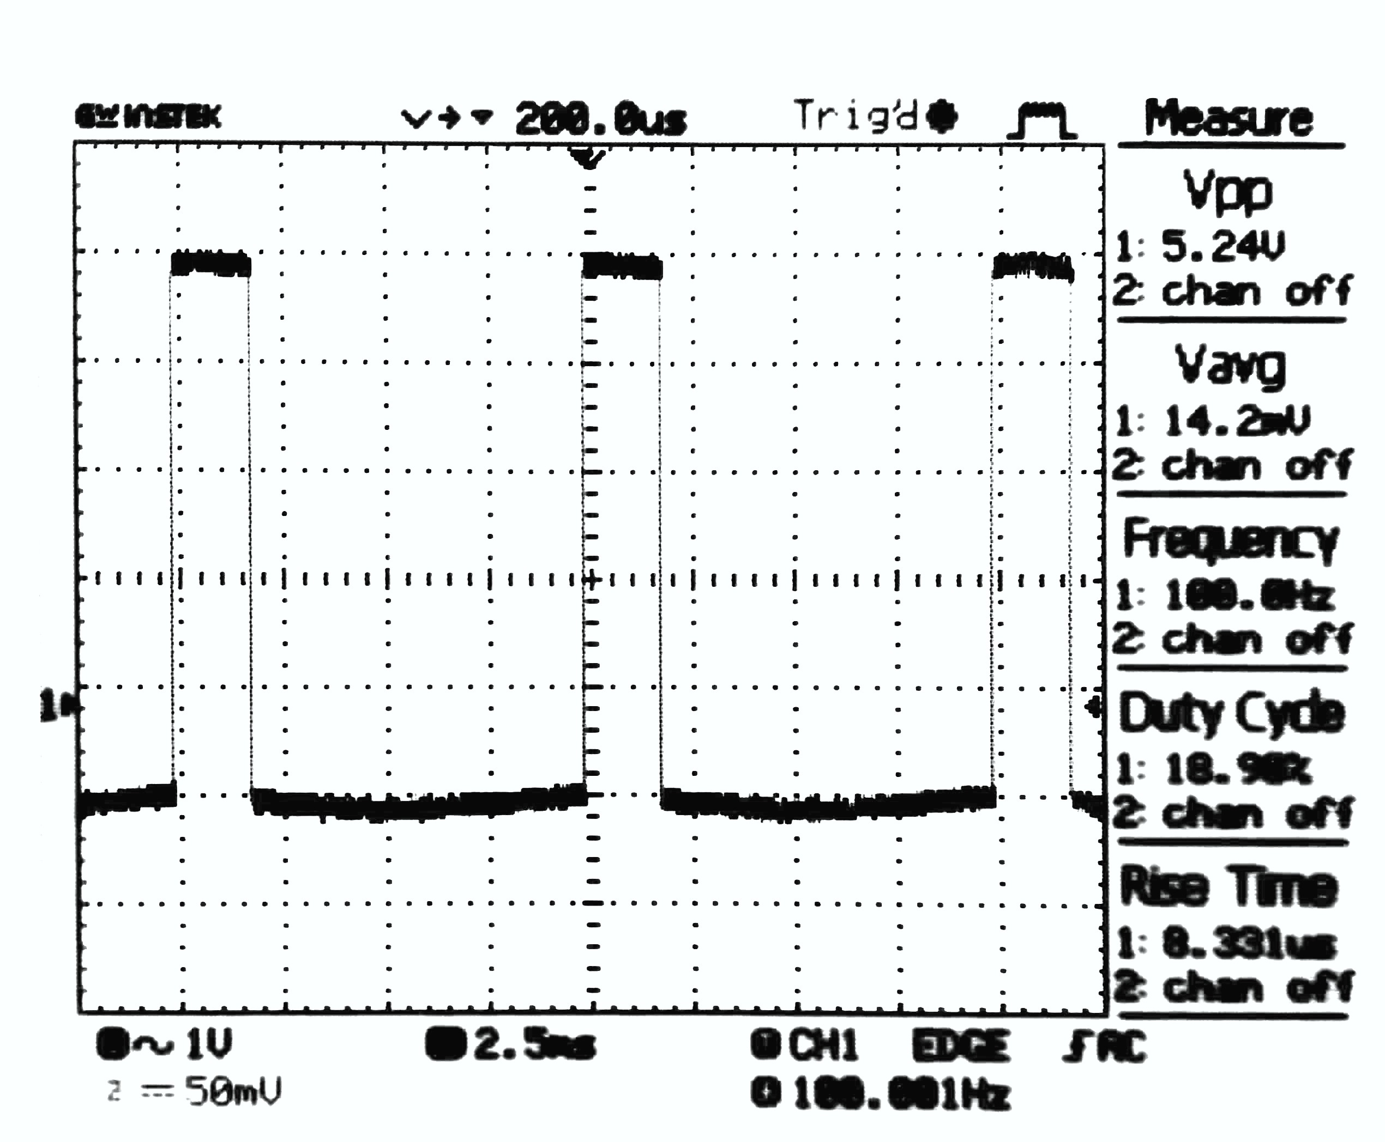

100kHz, Low duty cycle 100kHz, High duty cycle

**Discussions:** From this experiment we came to know about different duty cycles and their implementation. The function generator cannot output 0% and 100% duty cycle waves.